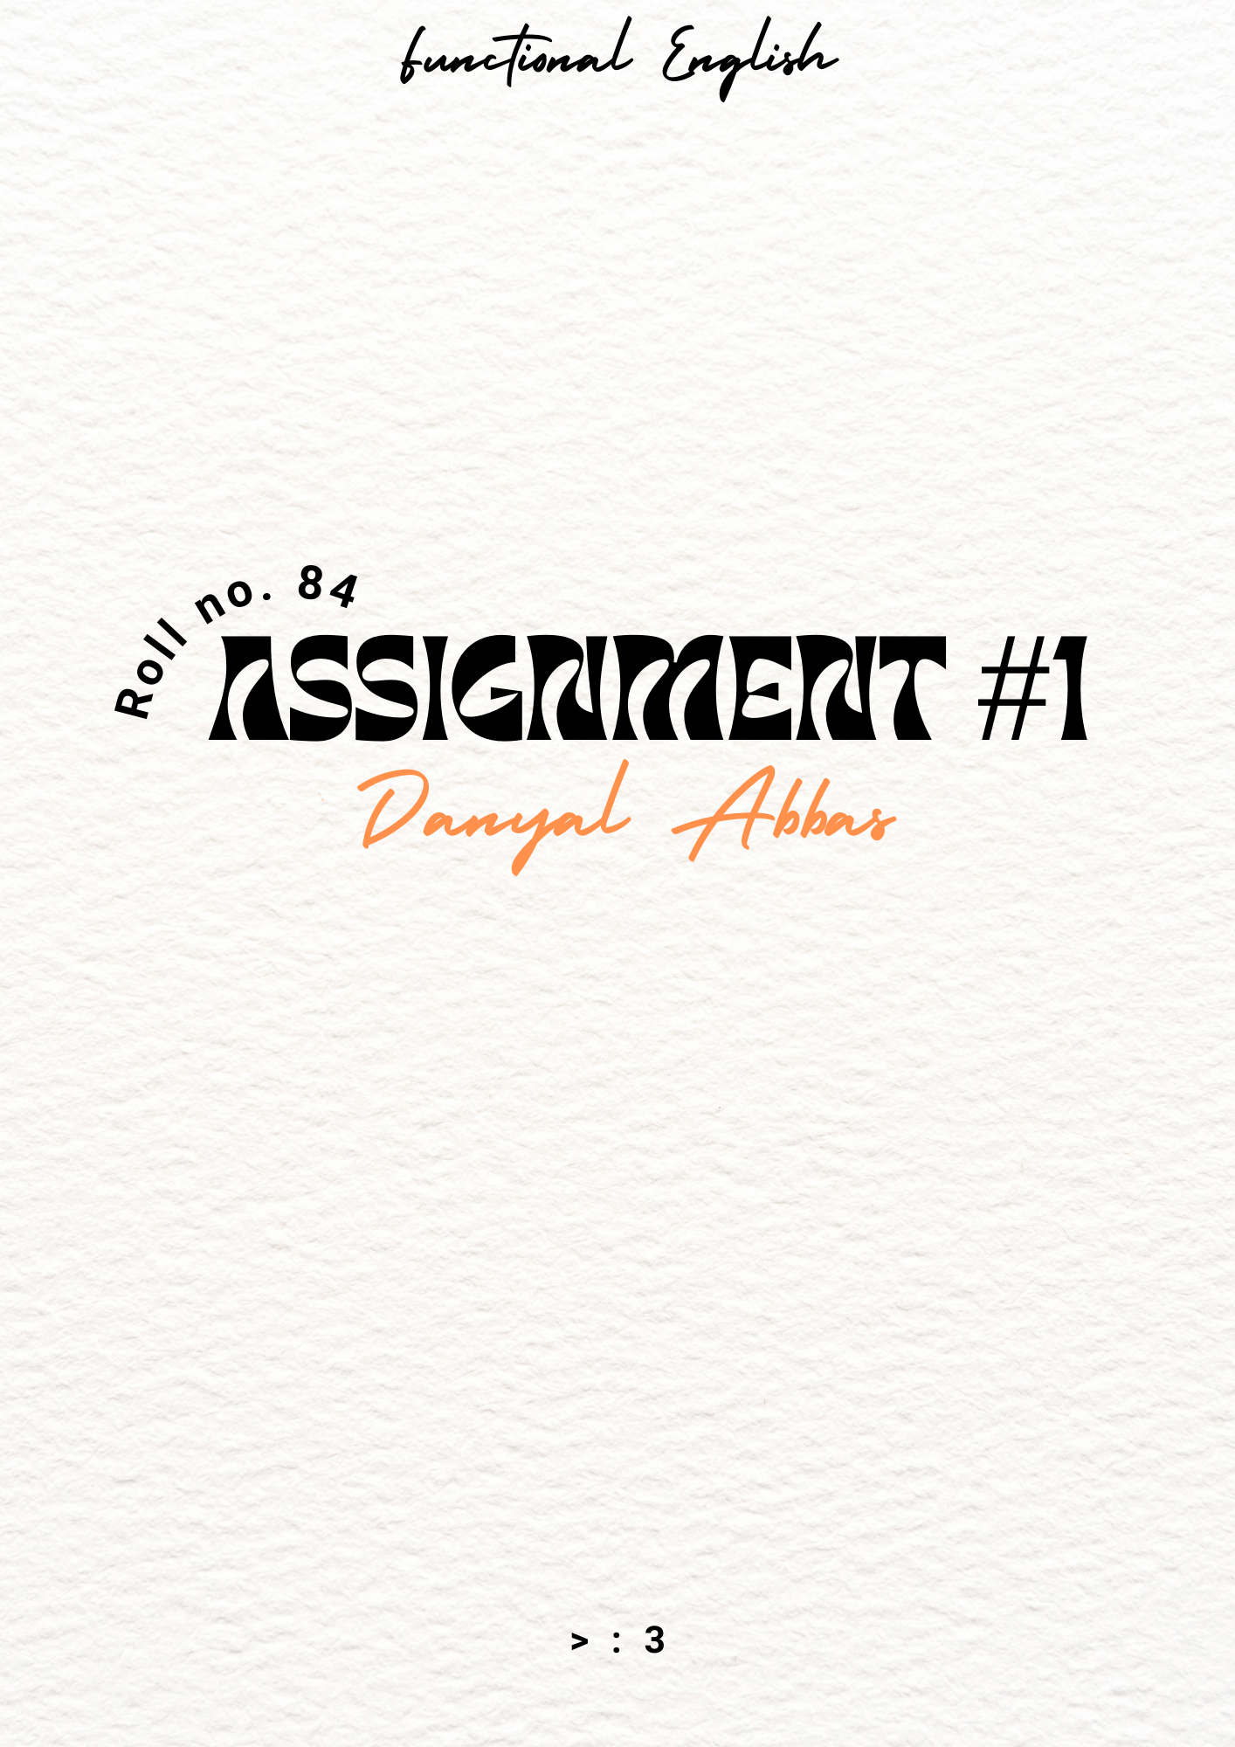

# **TASK #1**

#### **Concept Mapping**

**TASK #2**

#### **Think, Pair, Share**

* Mohatta Palace
* Omni Karting Circuit
* Turtle Beach
* Do Darya

**TASK #3**

|  |  |
| --- | --- |
| **Before** | **After** |
| 1) Karachi was a beautiful and clean city with lots of trees  2) Corruption was less and laws were strict  3) People cared about each other.  4) Robberies were not that much of a problem, and criminals were given their punishments.  5) There were no such problems of water shortage. | 1) People are not caring about Karachi and there is trash all over the city  2) Corruption has ruined everything  3) Everyone cares about their own benefit, even it involves hurting others  4) People are afraid to even go out because of the fear that they will get robbed, and criminals roam around freely with no justice being served  5) Problems of water shortage is becoming a headache now |

#### **Before & After**

**TASK #4**

#### **Questions & Answers**

#### Q1: **What are some of the concerns raised about the commercialization of Karachi's beaches and islands?**

Ans: The commercialization of Karachi’s beaches and islands is at the cost of depriving the people access to their only source of re-creation and depriving hawkers and low-income service providers of a source of income. Reclamation from the sea means increased flooding of the city, which we have experienced in the case of Defence society.

#### Q2: **How has the redesigning of Jahangir Park been received by some individuals?**

Ans: Jahangir Park has a rich history related to cricket and politics, which is not reflected in any way in its design. The victims of the design are children who played cricket here because they now play on roads and the old men who fed the birds around the ponds they had constructed.

#### Q3: **Do you think that involving citizens in the planning process is essential for building a sense of belonging to the city? Explain your answer.**

Ans: The main reason Karachi has lost its core essence nowadays, is because of our culture being polluted by the western dream, the reason for these uncultured designs are because the people of the city get no say in it. The builders should consult the people belonging to the city to learn more about the architectural history of the city.

#### Q4: **What changes can the teaching of social sciences and planning at schools make to the culture of Karachi? Explain your answer.**

Ans: Teaching the coming generations about the architectural history of Karachi can help develop sense of love for architecture in the younglings, and could make them more passionate about making Karachi a better place and culturally rich city.

**TASK #5**

#### **Reflection Karachi in 1900s**

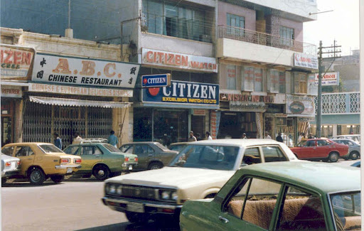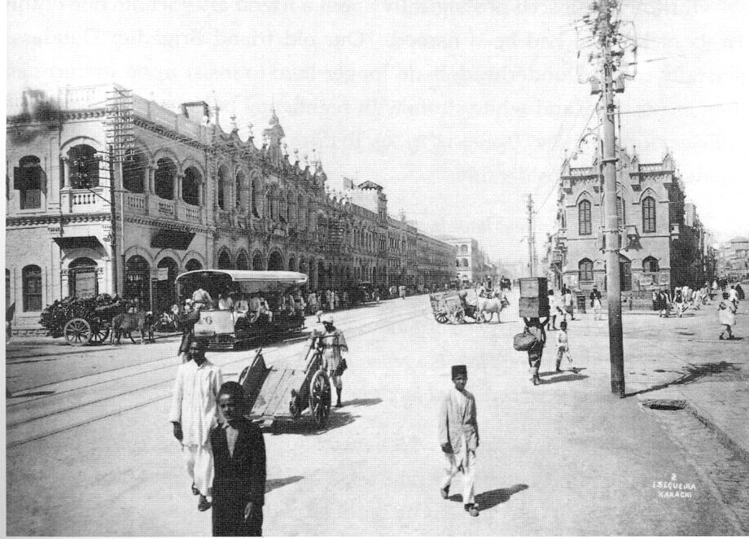

**Karachi in 2024**

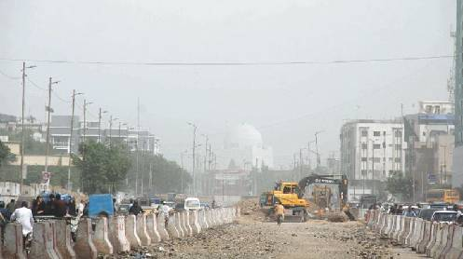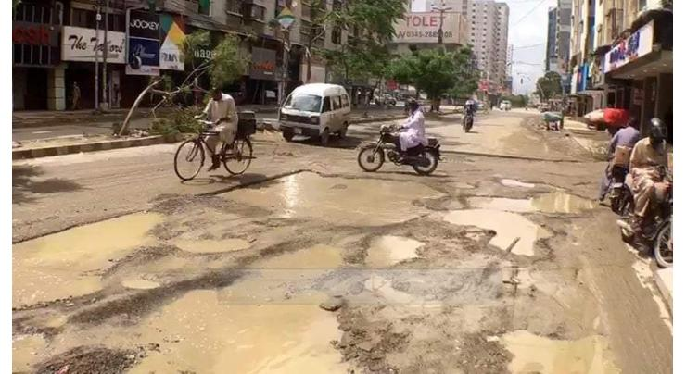

Above are two pictures of Karachi in the 1900s and two pictures of state of Karachi right now. The difference is very vibrant, where once Karachi held the image of one of the luxurious cities in the world in the 1900s, to now being a mere underdeveloped city in the country of Pakistan.

The pollution rate of Karachi is one of the highest in the whole world. Loadshedding, Water shortage, corruption has ruined it, making it one of the Top 3 most un-livable cities in the entire world. Every other road is filled with potholes and failed infrastructure. Crime rate is at its all time high.

In the 1900s, Karachi was known to be one of the most innovative city in the world, also being a education hub to a lot of students around the world. The streets were clean, The roads were well-made, Crime rate was low, and people didn’t feel scared to go out in the fear of getting robbed.

Looking at the pictures above, its not that difficult to deduce what timeline most of the people of Karachi would want to live in, but the situation of Karachi right now is not fully helpless. We need preserve our historical and cultural places and try to keep our city clean and once again make it a tier-1 city.